**Data Analytics Pipeline Homework 1**

**UNI:** hv2197

**Name:** Harish Visweswaran

**Question 1)**

**Hello World Example Tornado App:**

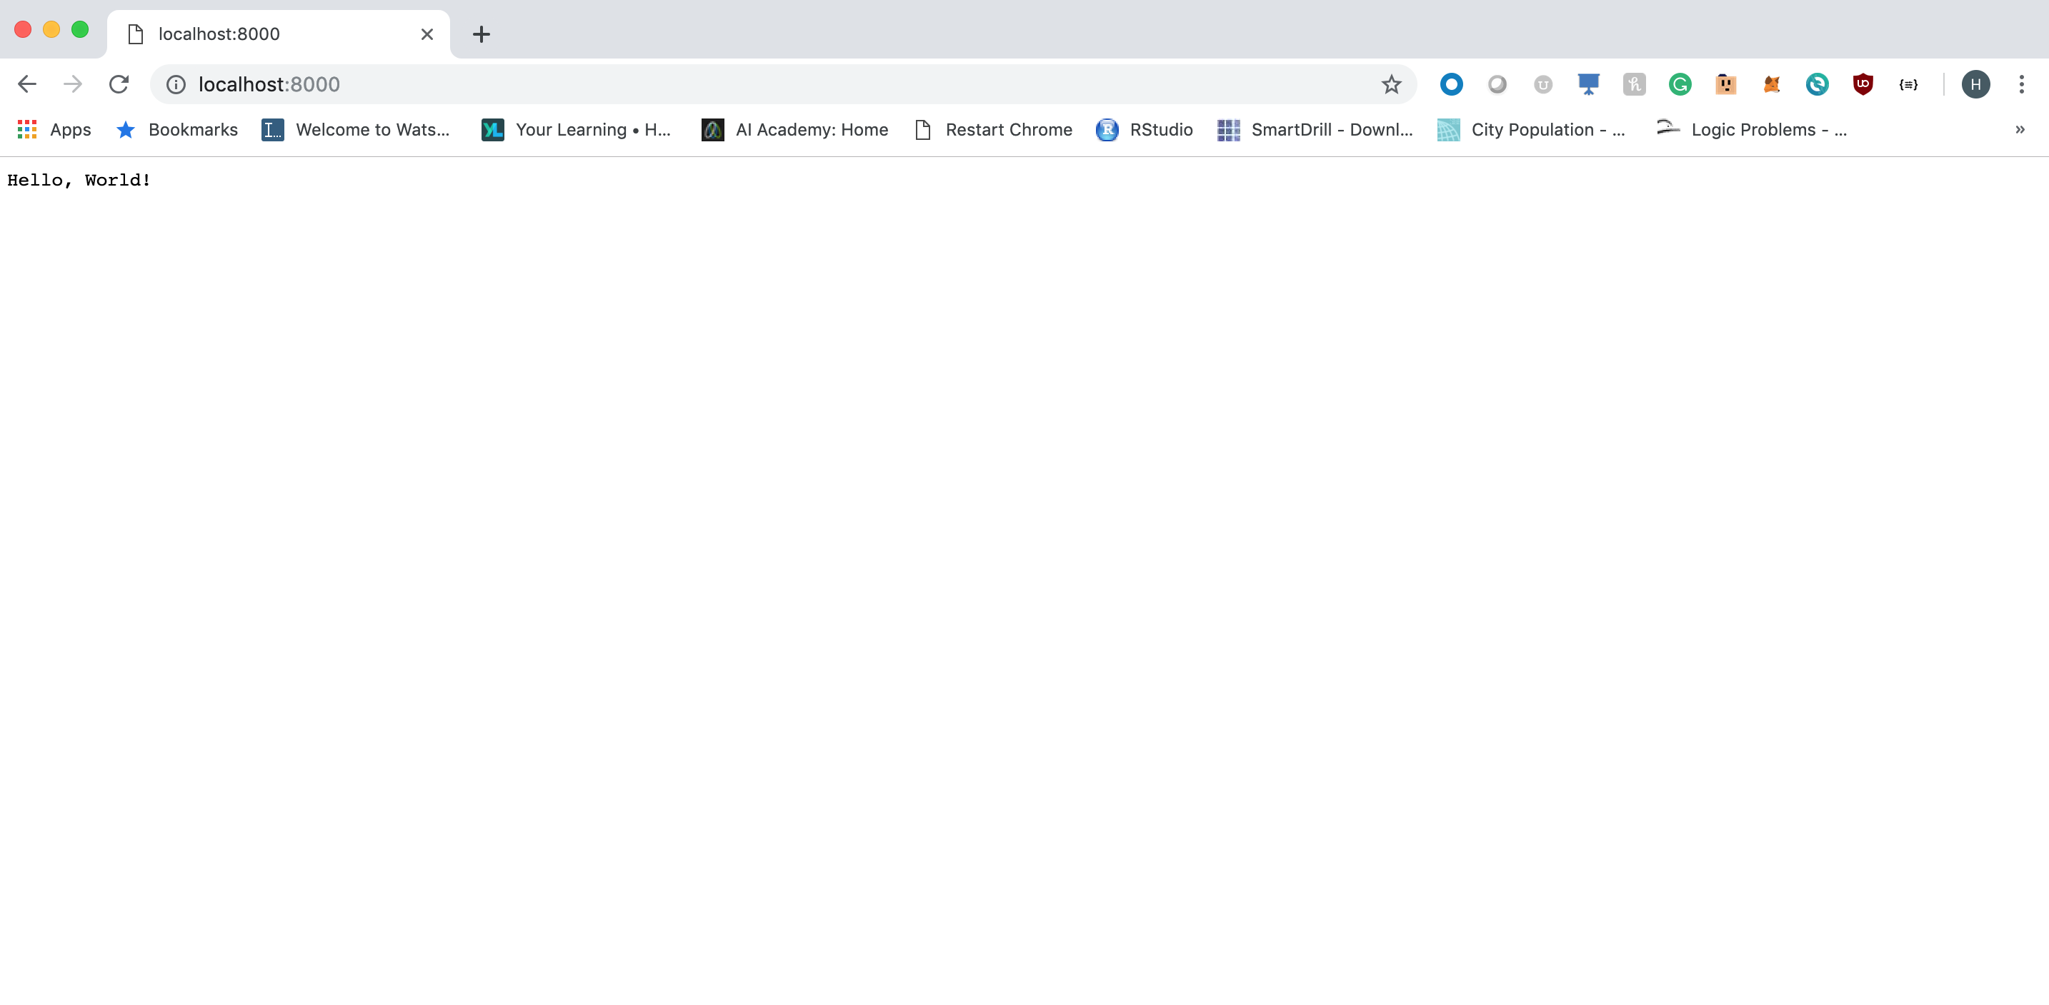

**Question 2)**

**Tornado App with Name Page**

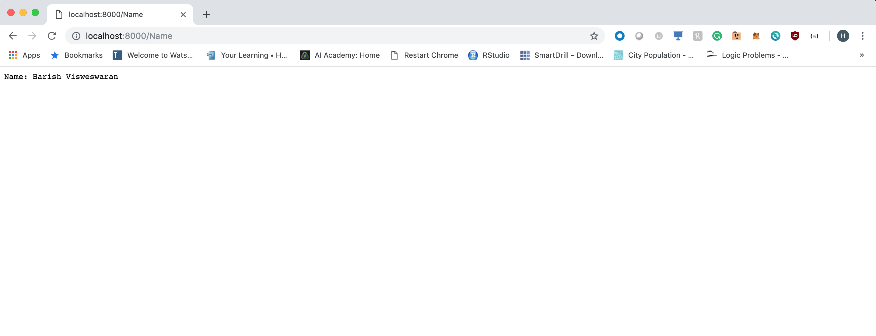

**Question 3)**

**Dash App with sample graph and graph of X vs X^2:**

**Screenshot 1:**

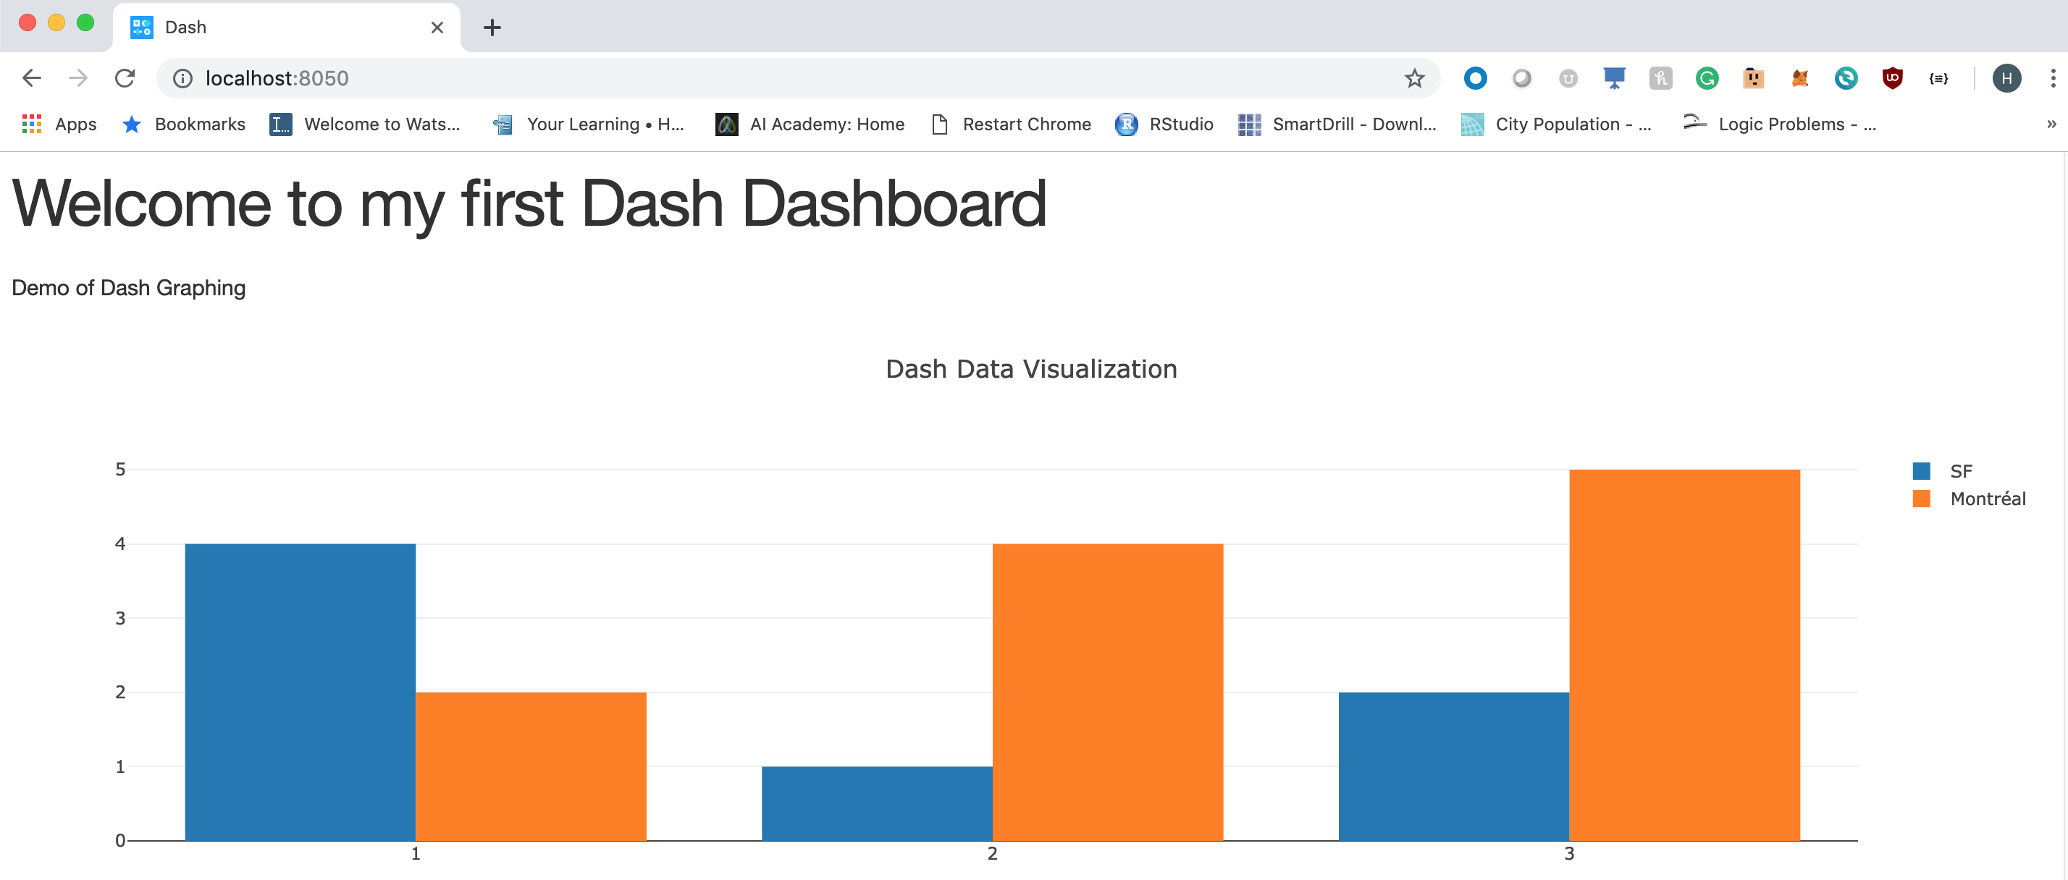

**Screenshot 2:**

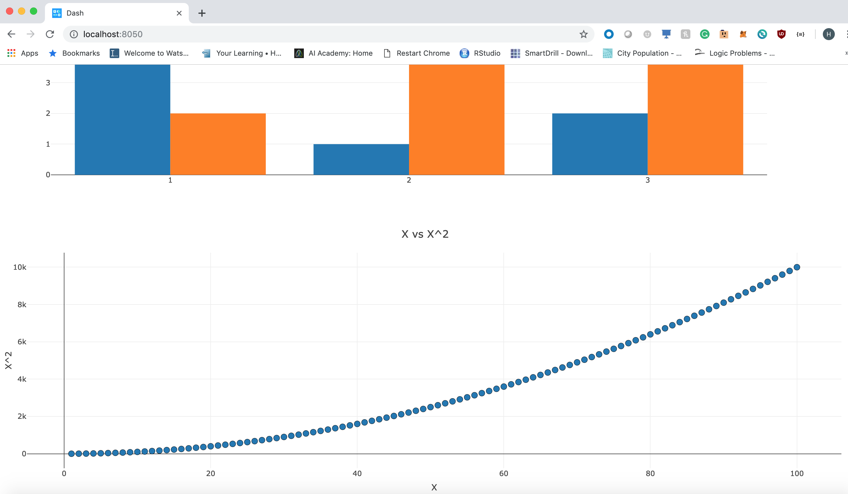

**Question 4)**

**Docker ps Output running the tornado app:**

